**Lampiran Praktikum 11**

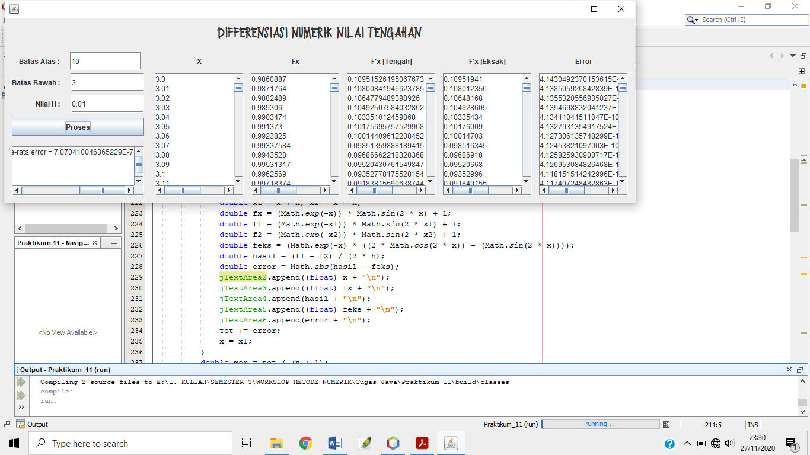

Listing Code :

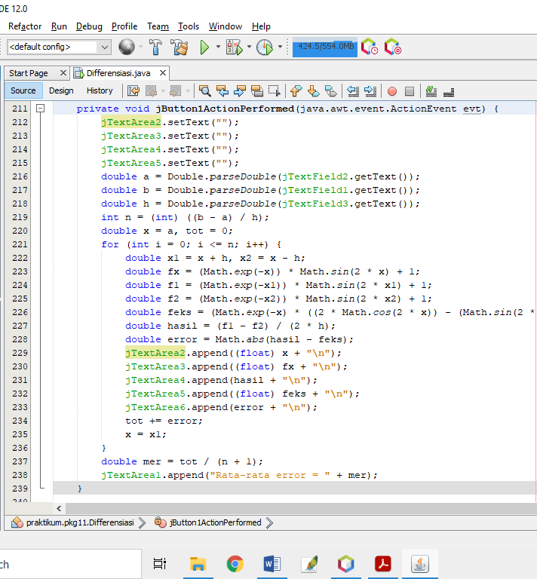

Tampilan GUI :

